CS 499 Milestone Four: Database Enhancements

Jennifer Tabor

Southern New Hampshire University

CS 499 Milestone Four: Database Enhancements

Brief Description

The app I am working on is a note taking app for job applicants. It will help to organize different jobs that a user has applied to. I based it on a personal portfolio application that I created in CS 360 Mobile Application Development that I was unable to retrieve from a broken computer. I began creating this new app during module one and completed it in module two.

Justification

This artifact will allow me to meet all the requirements of the final project by showing my skills in software design/engineering, algorithms and data structures and databases. I would like to improve my mobile application skills because that is the area I would like to work in someday, developing and maintaining mobile apps. By completing this project, I can show that I can create a working app from start to finish and that I understand the basic structures of development. I have made significant design updates since module one and two to the app by adding a login screen, Google maps, and allowing the user to save contact information for each job along with pertinent notes.

Course Objectives

I did find a way to save the contact information using shared preferences and created a database for the specific contact data. The user can save and retrieve contact data, but it is not functioning exactly the way I want it to. I would appreciate feedback on how I can improve it. I also am still working on saving the username and password with shared preferences so that the user does not have to keep entering their email and password when the app is opened.

Reflection & Challenges

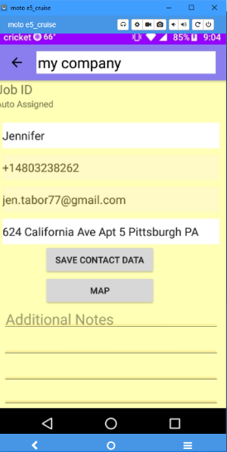The way I completed it is by first updating the layout for the note in the activity_note.xml file. I needed to add a field for the contact email address and a button that will be used to save the contact name, phone number, contact email and address to the database.

Next, I had to add a few classes to handle the database information that was being added. These new classes are Jobs, JobsDBHandler, and DatabaseActivity. While it is completely possible to hold multiple tables in an SQLite database for simplicity reasons, I created a separate database for the job contact information so that it could be completed on time since I am not sure how to alter the current database to create the new table in it. The files I added are based on the original application that was created in CS 360 Mobile Application Development (My Personal Portfolio app) which I modified to suit the needs of this new career search note taking app. JobsDBHandler .java shows the creation of the table and the rows which consist of contact name, phone number, contact email and contact address.

The notes section saves the data and displays it and at this point but if no characters are entered into the note portion the company will not be saved. Using shared preferences, the contact information can be saved and retrieved but it only retrieves the very last contact information saved and is not specific to the note that is saved. I want to figure out how to save and retrieve the very data saved inside each different company note. While I am glad I can save the contact information and retrieve it, but I need to keep searching on how to get it to operate the way I need it to. I may try to put the save and retrieve methods inside the methods for saving the additional notes and company name somehow so that each note has the right information in it.

Each week I learn more about application development. I have run into many challenges due to my lack of experience which makes it vital to research different methods of achieving my goals. I have learned how to implement functionality in the buttons and edit text fields, how to create a SQLite database as well as the limitations and benefits of shared preferences. I think being able to research solutions is a key to completing a successful project.

